DANGEROUS DUCK, PART II
By PolySail Dave

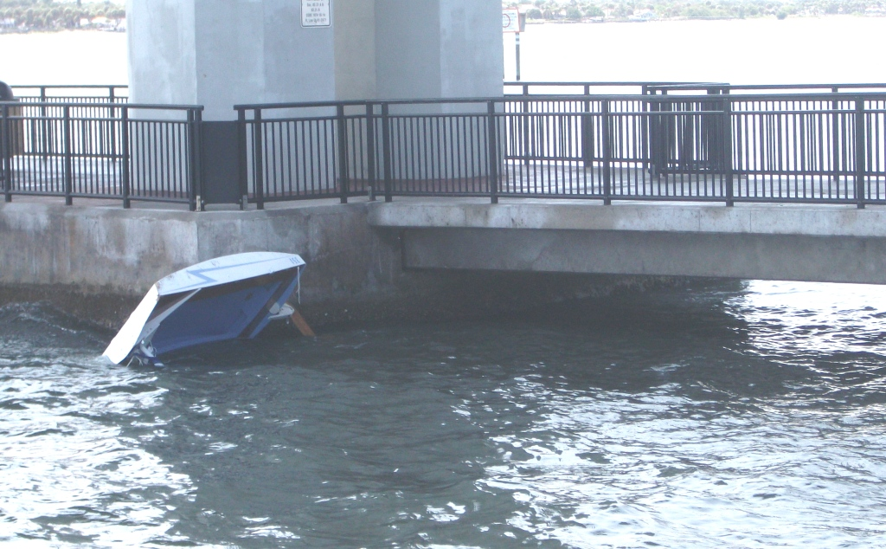
This is the second installment of my threat to build a contender for the 2012 PDRacer World Championship–a PDR that I have already christened Dangerous Duck. Those of you who read the first installment will recall that my sure-fire winner of the 2011 worlds, Wild Duck #143, the biplane-rigged duck, mysteriously went up in flames along Florida’s Turnpike, while my other duck, the Z-PDR #351, had been chewed to splinters earlier in the summer as she floated helplessly at the base of the Hutchison Island Causeway. My bad duck luck in the summer and fall of 2011 had been exceptional, and suddenly I realized that I was without an operational PDRacer for the first time since 2003.

That realization nearly overwhelmed me. Three years before, when I had lived in Indiana, I had a ready fleet of three PDRacers at my disposal when I walked down the slope to the water’s edge from my home on Lake Vista. I had sold Lame Duck #100 and Webfoot # 199 when I moved to Florida in 2009.
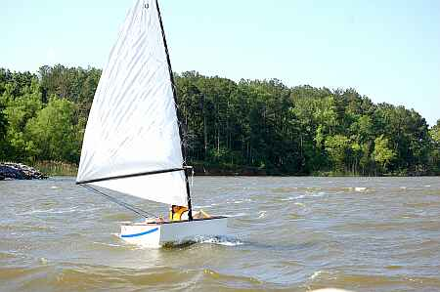 | 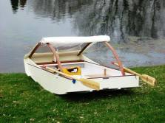 | 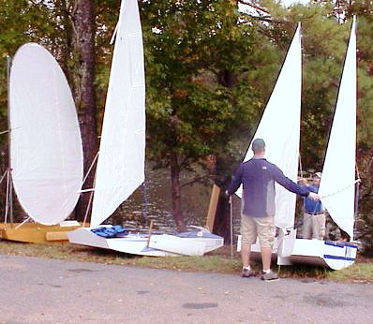
LameDuck #100 sailing in strong winds at the Midwest Messabout at Lake Rend, Illinois. Lame Duck was a standard 16” freeboard PDRacer built in 2003. Plans for building her are still on my website, but there were many changes by the time I offered PDR kits that were built at the 2010 Wooden Boat Show. | Webfoot #199 about to undergo float tests on Lake Vista in Fishers, Indiana. Webfoot had a foam and ‘glass bottom and had 2” foam sides that had to be added on to make the boat a class legal 48” wide. | Ryan assists me with the rigging of Wild Duck #143 at the 2009 Worlds at Allatoona Lake, Georgia. Ryan’s Z-PDR #351 sits next to us while John Wright’s innovative PDR with its oval sail sits next to the Z. (Tim Cleary photo)
I brought Wild Duck with me to Florida then built the Z-PDR so that my son Ryan could sail with me in the 2009 Worlds. Now, here I was with water everywhere I turned, duckless in Florida—it reminded me of a title for a tragic novel—and I moped around the house for most of October even though my loving and sympathetic wife had hinted that I should build a replacement for Wild Duck. Finally, Dixie tired of my behavior and banned me to the garage where I puttered around with a few scorched boat parts that had somehow survived the turnpike trailer fire.

Late in the month I received a phone call from Mr. Marc Krawatsky who lived about an hour south of me. He wondered if he could arrange a time in November to have his seven-year-old son try out a PDRacer to see how he liked it. His son had been trained in Opti’s, but the idea of spending three grand for an 8’ pram was bothering Mr. Krawatsky. Suddenly my funk just disappeared. It was time to get cracking; I was motivated again! Wheels began turning, neurons began firing, and plans began taking shape in the old cranium. Soon I was back in the office sketching out plans for a suitable replacement for Wild Duck and working through my options for a purpose-built PDRacer. I knew that Brad Hickman and Scott Widmier were both planning non-polytarp sails for their boats for 2012, so to continue the legacy of Brad Hickman’s 2011 win flying a PolySail was a given. This new boat had to be an all-out racer that could put up enough sail to be a threat in any conditions. “PDRacers Take no Prisoners” was the tag line for my Dangerous Duck t-shirt, so Dangerous Duck seemed a fitting name for my next boat.

Here’s my first sketch for Dangerous Duck. 67 sq. ft. doesn’t sound like much of a sail, until you realize it says times one or two. That’s right. Dangerous Duck will have a biplane rig option, an inboard pivoting daggerboard, a 12” or 13” freeboard, and weigh under 80 pounds.

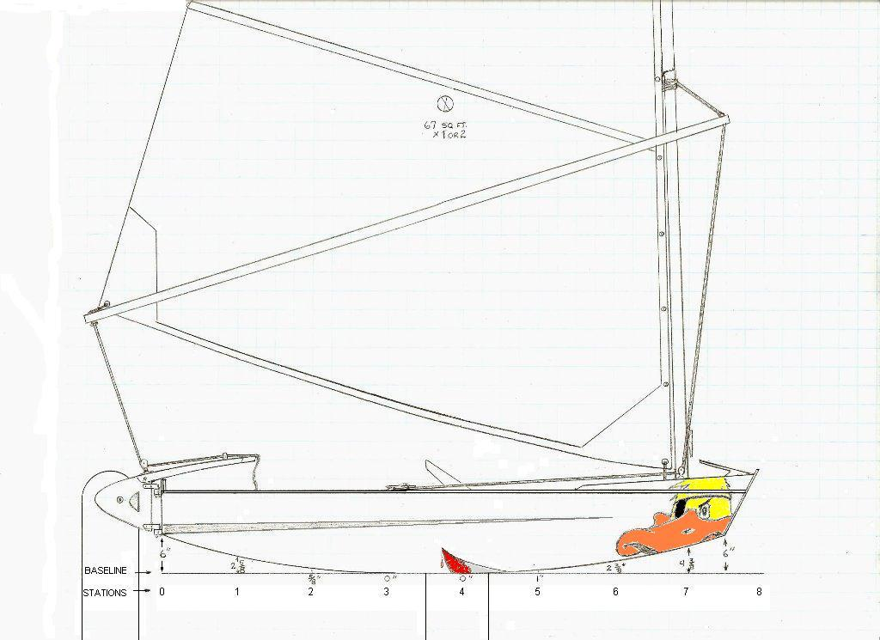
But before I could build her, there was still this obligation to meet so that a young man wouldn’t be disappointed in not having a PDRacer to sail when he and his father came to town on Sunday, November 20th. That meant I had better get busy and restore the Z-PDR, at least to sailing condition. For backup I appealed first to Patrick Johnson who was not far away with his PDR Redrum and Commodore Perry, the sailing prairie dog. Patrick graciously agreed to meet us at the public ramp beside the US Sailing Center in Jensen Beach. In the meantime, I sent out a general invitation to other Florida PDRacer builders based on Shorty’s registration list–might as well be a messabout, I figured.

With few sails to make in October, it wasn’t long before the Z was beginning to look like a PDRacer again instead of Shredded Wheat. In spite of being constructed from the cheapest lauan offered at Home Depot, her hull was still intact. With all her thickened epoxy repairs, she’s now a few pounds heavier and retains a few scars from the pounding she took, but she’s once again seaworthy. I think that her ability to absorb the punishment from the barnacles at the foot of the causeway pilings speaks pretty well for the strength and shock absorbtion power of her Styrofoam insert as backup for her 3/16” hull. But then NASCAR builds SAFER barriers of the stuff, and it was originally developed for Coast Guard lifeboats–what’s not to like about Styrofoam as a boatbuilding material? I’ll use it again in Dangerous Duck, I decided.

Here are a few recent photos of the restored Z-PDR:
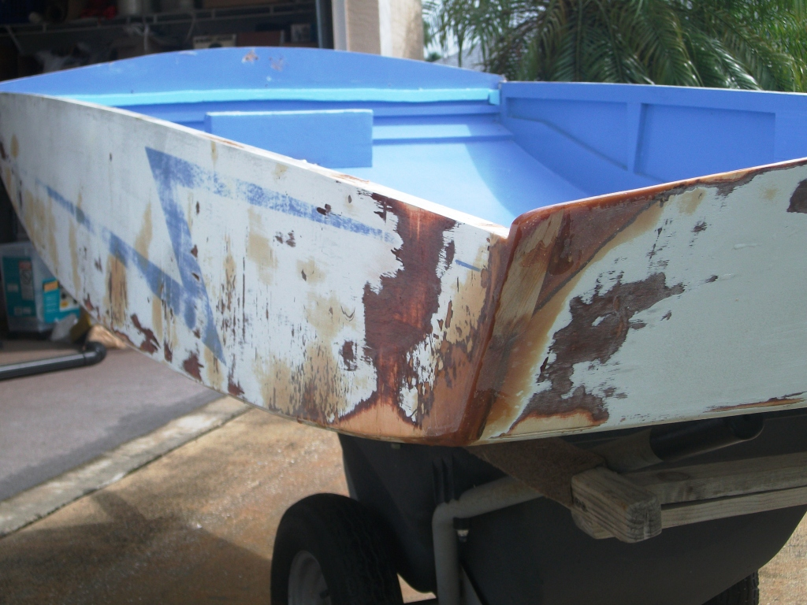 | 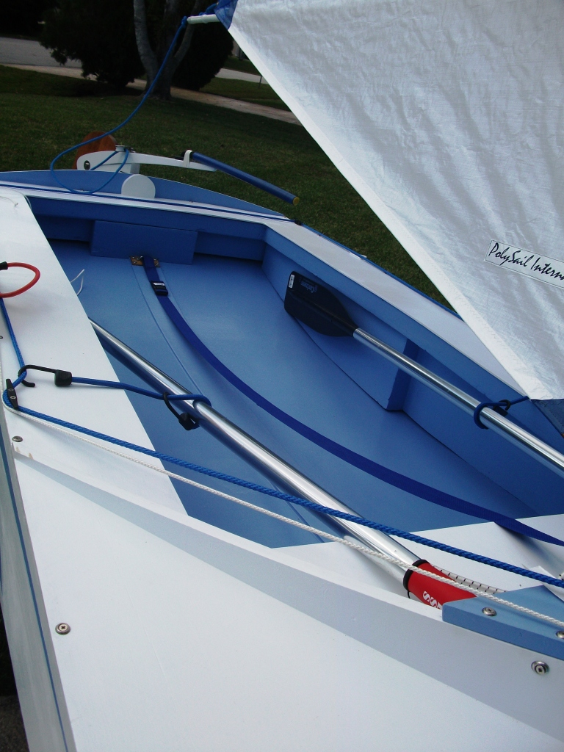 | 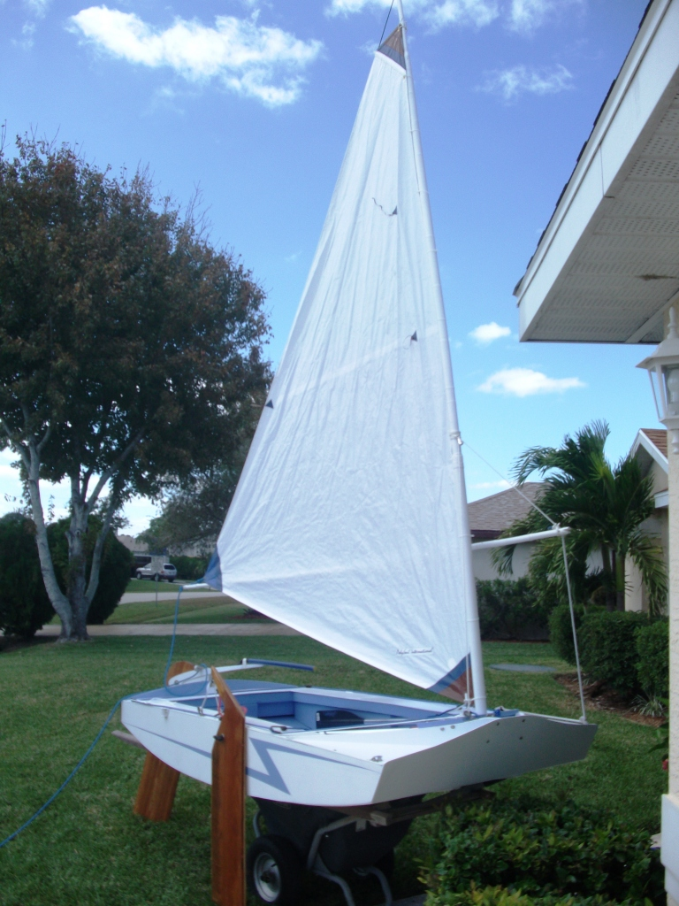
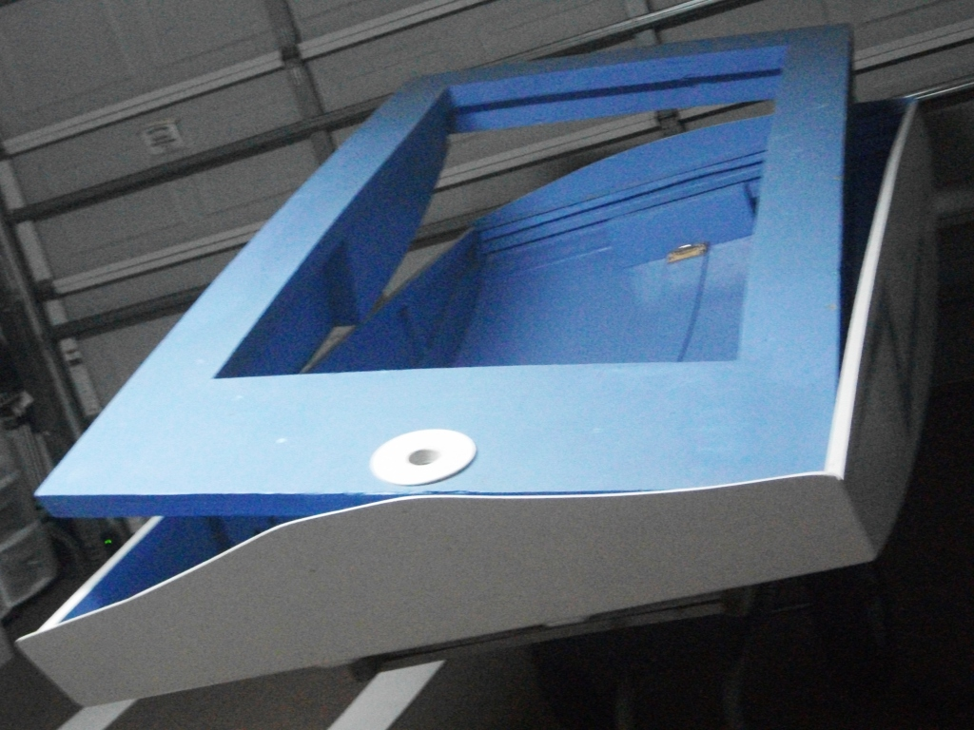
Top: Epoxy repairs to the starboard bow corner were extensive.  Bottom: The Styrofoam insert was removed, repaired and repainted and is about to be reinserted in the hull shell. | The deck is no longer natural, but the cockpit is still very functional. Lightweight aluminum oars replace the wooden oars that were burned in the fire. The tiller had to be cut down because of fire damage, but I added a flexible extension that might work well for hiking out. | Here I am taking a look at the Z with a small 40’ shoulder o’ mutton sail that I used on Wedgie, the little 7’ kid’s scow that was also consumed in the fire. Depending on the winds, I might put up a larger sail for the trials.

As I put the final touches on the Z-PDR for Sunday’s meeting, I’m just a little apprehensive. I won’t have a chance to try her out before she’s put in the water on Sunday. Will seven-year-old Levi Krawatsky be satisfied with a PDRacer? Will the Z perform up to expectations? Will my 2011 duck luck finally change?

To be continued….

