Build DANGEROUS DUCK, A Serious PuddleDuckRacer

WORKSHOP #2: HULL PLANS

This workshop focuses on building the hull for Dangerous Duck from either lightweight marine plywood or lumberyard materials. The drawings below are the best working representations I can put together with my limited knowledge of blueprints and drawing software. Please be patient with my efforts and send questions if there is something that is not clearly shown.

Here’s the basic side view of Dangerous Duck:

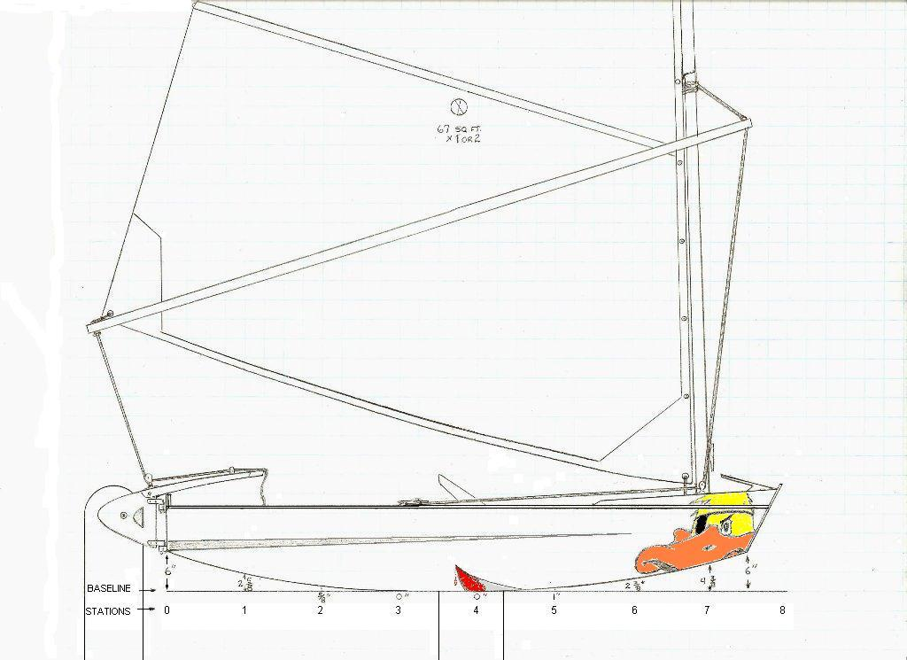

I’ve already altered some parts slightly, but the basic concept is as pictured. The overall design calls for a lightweight PDR with a lot of open cockpit and just enough deck to hike out. It’s a compromise, as are many boat design decisions. In this case the purpose is to allow either sitting inside or on the gunwales. If I am sitting inside, I like to be able to move my “ballast” as close to the rail as I can and still stay inside the boat when a gust hits, so I want a wide cockpit and a narrow deck at the sides. If I still had the abs to hike my ballast out over the rail, I would want a wide deck to support me when I’m hiked out. By creating some simple deck extensions, I think I have covered both options There are other little refinements that will become apparent as we move through the plans, so let’s begin.

In Workshop I, Preparations you were advised to make decisions about whether you would build the lumberyard version or the high end version of Dangerous Duck. This workshop assumes that you have made that decision and sought out the lumber you will need for building the hull. Below are the cutout plans for the three panels you purchased for the bottom, the sides, and the deck:
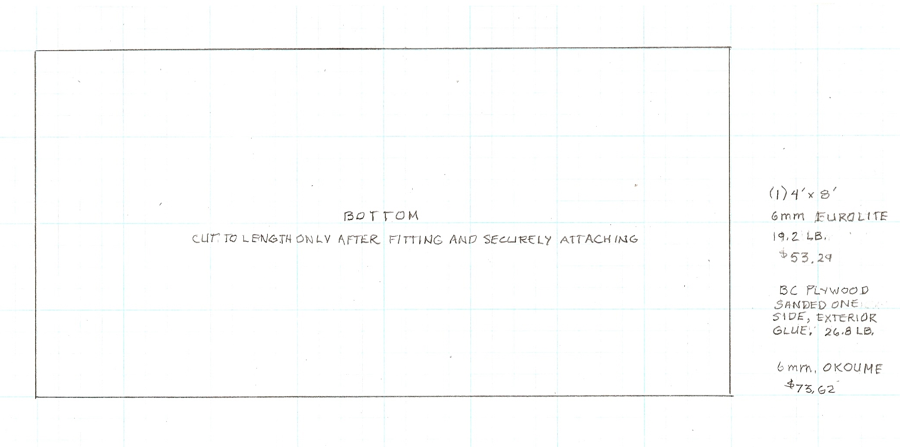

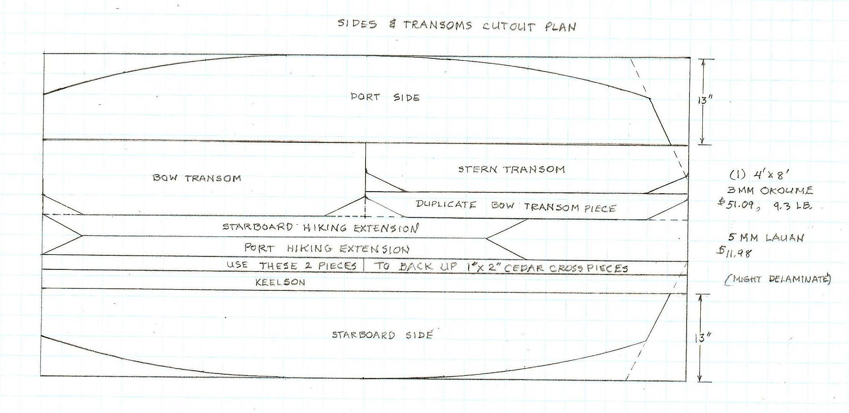
If you buy this piece from a big box store, you can usually have one of the store employees cut the two 13” sides out of either side of the full panel. If you take along this
drawing, you might be able to get the keelson and the cross piece backup pieces cut out at the same time.

You will probably have to do your own cutting of the deck shown below. After marking out the lines, you might want to use a combination of a circular saw and a jig saw to cut out the center. Use the circular saw to make the longer cuts and the jig saw to cut the angles and the corners. If you can slice down on the line with the circular saw to begin your cuts, you might be able to use the inner part of the panel as a covering later.

TIP: When cutting across the grain of plywood panels, I always cover the cut line on the good side of the panel with packing tape then rub it down well on the cut line. The tape prevents ragged splintering of the end grain when you make the cut.
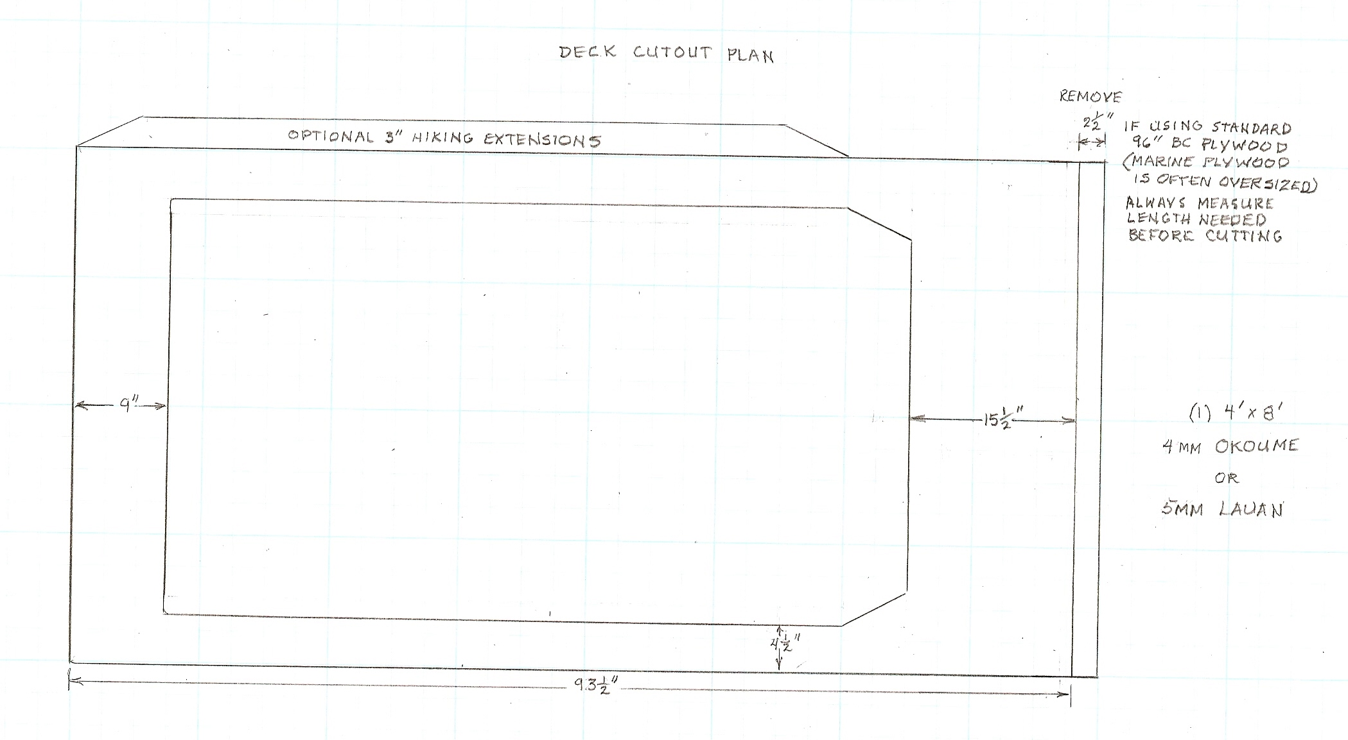
I have plenty of templates for the side cutouts, but I still like to measure everything before I cut the rocker and the bow angle. I usually start by cutting out the rocker and bow angles on the ¾” x 8’ x 8’ planks that I use for framing the lower half of the sides. Because the sides are so thin, I like to have a strong framework to back up the side panels, so I do a lot of work on these two planks to lighten them and still provide backup for the side panels.

After I cut the planks to size, I set them up together and plane and sand them until they are identical After the panels are cut, I follow the same procedure with the panels. Before I glue the framework to the panels, I make certain that I have cut out the insets for the cross pieces that fit at either end of the framing plank. The ends of these cross pieces will then be covered by the side panels once the panels and framework are mated.

Once the side panels and plank framework have been glued, position two of the ¾” x 2” x 8’ pieces of cedar or pine at the top edges of the two side panels. Position these pieces so that they fall about 3/16” short of the stern end of the panel so that the stern transom and framing will fit inside the two side panels and the sides of the stern transom will be covered by the side panels.
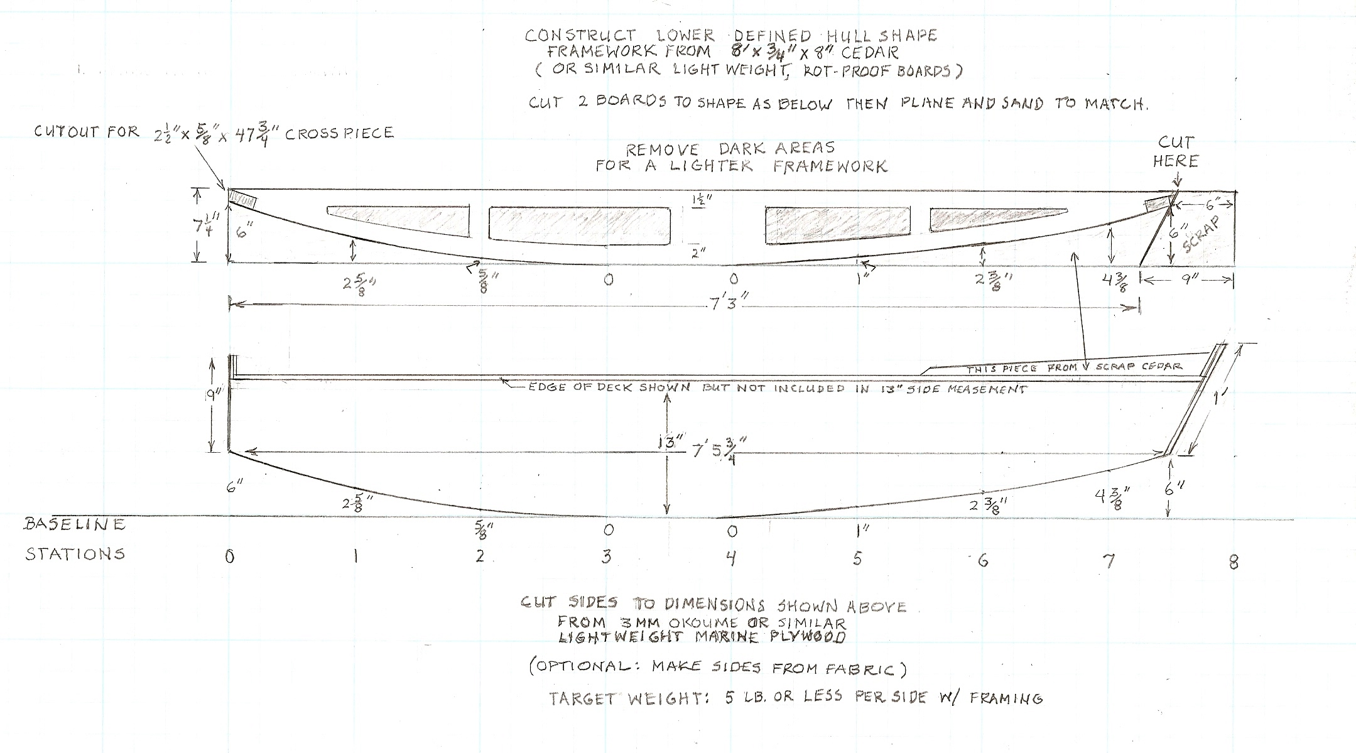

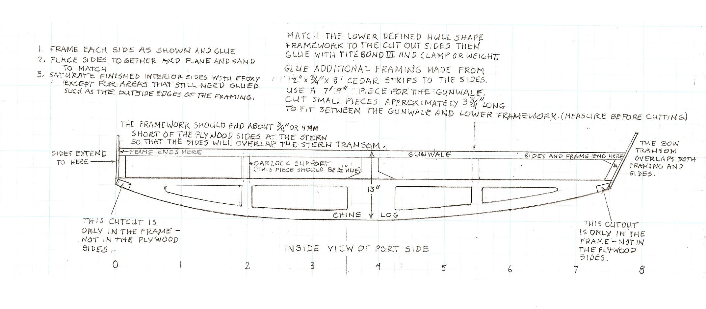
Once the side panels and framing have been mated and glued, it’s time to turn your attention to the bow and stern transoms. The plans for the transoms are shown below.

The upper parts of both the bow and stern transom extend up past the sides to provide additional splash protection in rough weather. These upper parts are reinforced with duplicate pieces of the tops of the transoms for additional strength. There is no duplicate top piece shown in the cut plan for the stern transom, but one can be made from one of the two pieces identified as “backup” for cross pieces.
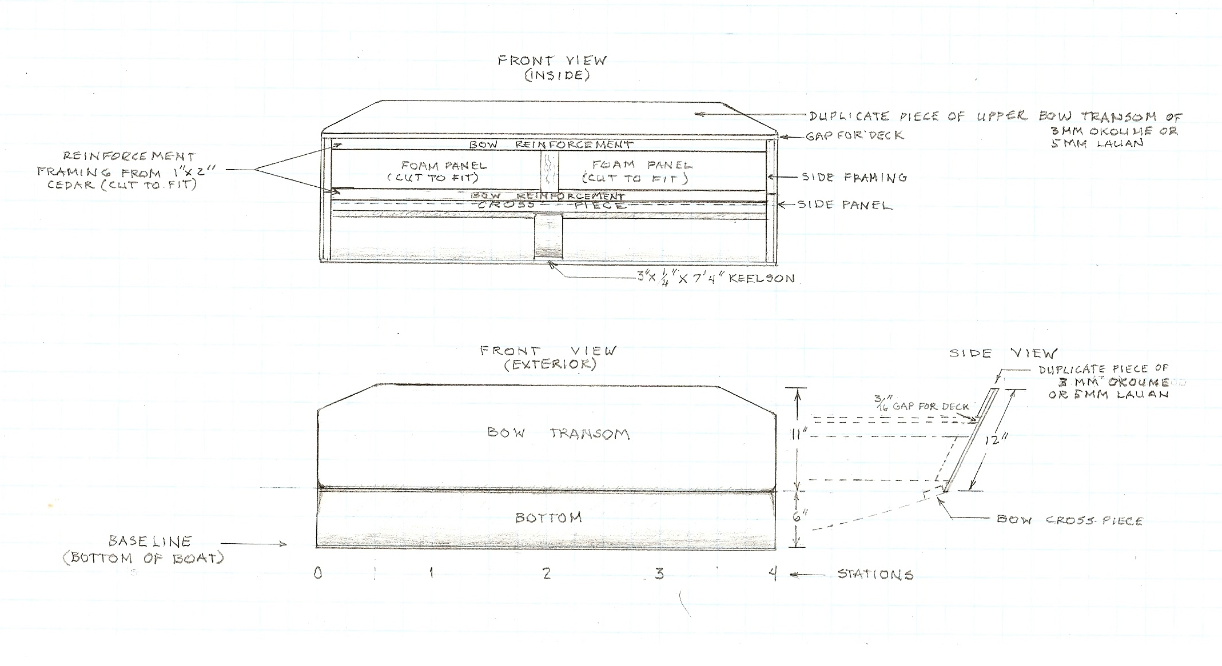

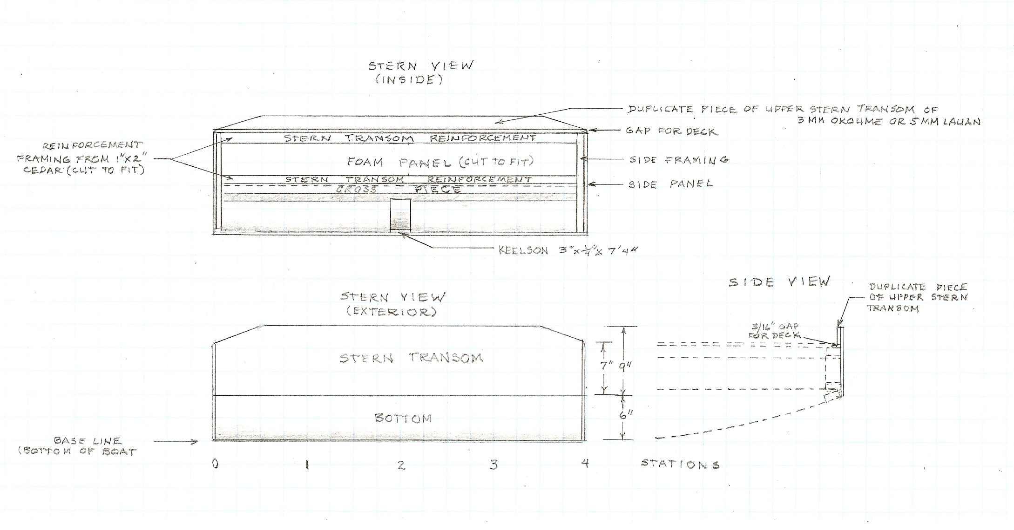
Once the side panels and transoms ate mated to the framing shown, the panels can be squared up and temporarily screwed together. After making certain the parts are square and level, dry fit the bottom and temporarily screw it on. When you are certain all is square and level, glue and nail the bottom on. I recommend using PL Polyurethane in the caulking tubes for the bottom adhesive since it is both waterproof and gap filling. Use bronze or stainless steel ring nails for attaching the bottom. Be careful about using too much glue if you are planning to finish your boat natural. Runs can leave marks that no amount of sanding seems to be able to remove. After the dry fit, I will usually cut enough from the bow end of the bottom so that it will still overlap the bow transom slightly when the bottom is attached. Then I finish the bow angle by planing and sanding the joint to fit.

The target weight for the unfinished hull is 50 lb.

Below is a top view of the deck after the hiking extensions, mast partner, bow support frames, splash shield, leeboard cutouts and dashboard are added. However, there are several pieces that need to be completed before the completed deck can be added, including the foam insert that supports this lightweight decking. Plans for construction of those pieces will be the subject of Dangerous Duck Workshop III.
