2291 SE Gaslight Street
Port Saint Lucie, FL 34952
Phone: 317 385-3444
polysail@polysail.com

Quick Sailmaking Guide
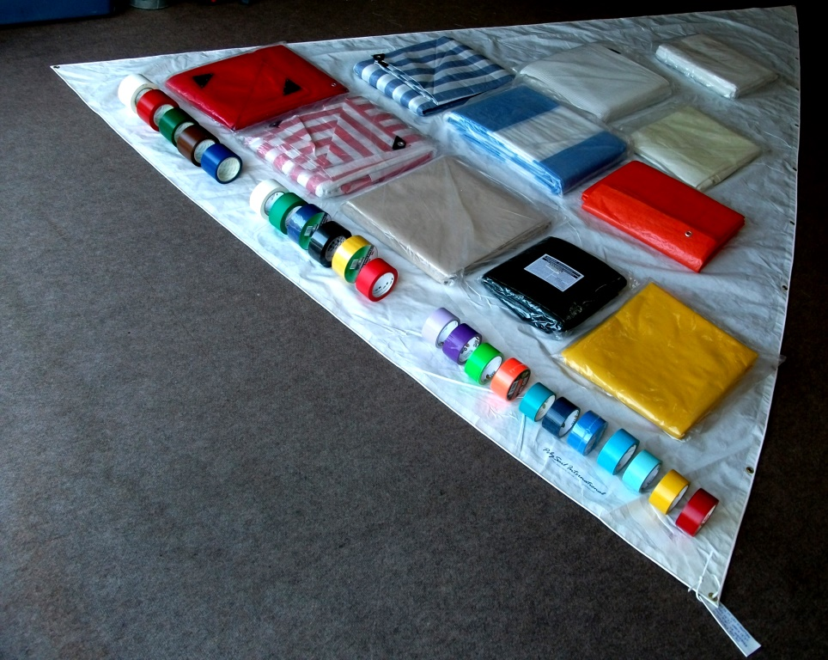
1995 I build the first white polytarp sail, a Bolger 59 sq. ft. leg o’ mutton, for my Bolger Cartopper .
1996 I introduce white polytarp sailmaking kits on the Internet and at Jim Michalak’s Midwest Messabout at Rend Lake, IL.
1997? Chuck and Sandra Lienweber construct a Michalak Caprice sail from one of our 15’ x 20’ kits. They sail their boat in the first Texas 200.
2003 The PDRacer is introduced as a cheap, creative, and fun class boat with most PDRs flying polytarp sails.
2006 I retire from the University of Oklahoma and begin devoting more time to the white polytarp sail business. The name is changed from PolySails to PolySail International
2009 My wife and I move from IN to FL to be close to our new grandkids. I participate in the PDR Worlds near Atlanta. My son ties Michael Storer for 4th. I am 9th.
2011 and 2013 PolySails power the winners of the PDRacer Worlds. We begin publishing yearly calendars of small boat events to raise money for good causes.
2011 Mike Monies and Andy Linn enter Scamp #2 powered by PolySails in the 300 mile Everglades Challenge but founder in the mud of Florida Bay.
2012 I participate in the PDR Worlds at Lake Arthur, PA and place 7th after capsizing in race 3.
2013 PolySails are selected for a catalog photo shoot for DXL clothing. PolySails are chosen as prototype sails for a 16’ $9000 composite Pacific Island sailing canoe by Offshore Cats.com
2014 Spirit is launched by the Crystal River Boatbuilders with the largest polytarp sail ever—a 507 sq. ft. gaff mainsail. I participate in the 2014 PDR Worlds at Magnolia Beach, TX. We provide sails for an
entire fishing village in Haiti.

This is a good place to briefly, but effectively, summarize your products or services. Sales copy is typically not included here.

A Brief PolySail History
PolySail International

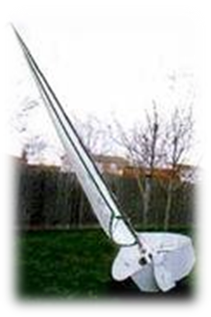

We cannot direct the wind, but we can adjust the sails
–German proverb

Sail /sāl/noun/ A piece of material extended on a mast to catch the wind and propel a boat, ship, or other vessel. "all the sails were unfurled” synonyms: canvas, sailcloth materials
–Oxford Dictionary

1. Select the Material
Select the weight, size, color and quality of the poly laminate sheeting you will need according to your sail plan and intended use. The larger the sail plan and the more extreme the sailing conditions, the heavier the weight and the better the quality should be. See our sailmaking kits at http://polysail.com/Kits.htm

2. Lay Out the Material and Sail Plan
Select a clean, dry work space. Unfold the material and weight or stake the corners and edges. Half concrete blocks work well. Transfer the outline of your sail plan to the material using an erasable marker and straight tape measure(s) to mark dotted baselines. Align the leech (back edge of the sail) with the long edge of the material. Add and tape and/or sew down all shaping darts needed. Then use double-faced tape to outline the actual shape of the sail including the rounding and hollowing that will give shape to the sail.

3. Cut Out the Sail Plan
Use very sharp scissors to cut around the outside edges of the double-faced tape then remove the scrap from the work area.

Step-By-Step Instructions

4. Add Reinforcing Line and Fold Over the Taped Edges
Remove the backing on the double-faced tape one sail edge at a time. Beginning at the highest point on your sail—the head on 3-sided sails or the peak on 4-sided sails—leave about 6” of extra line then install the reinforcing line along the inside edge of the double-faced tape along all edges of the sail while keeping tension on the line and material using weights to hold down the corners. Fold the exposed taped edge evenly back over the line as you work each edge of the sail. Finish at the head or peak by overlapping or doubling the ends of the reinforcing line and sewing or taping the ends together.

5. Add Reinforcing Tabs and Tape to Each Corner

6. Add Grommets
Set brass grommets at regular spacing along edges and corners of the sail that will be attached to a mast, boom, spar, or mainsheet. PolySail grommet kits are included with each sail kit and contain separate instructions for setting these grommets.

7. Attach and Rig the Sail
Use one of the many lashing options shown in our more detailed instructions on our library page at http://polysail.com/library.htm to attach your new sail to the mast, boom, and/or spars. You can also use the zip ties we include in our sail kits to attach your sail for testing. Later, the ties can be replaced with hoops or one of the lashing systems.
Each sail type requires different rigging, and for most of the sails home boat builders construct, we recommend David Nichols’ book, The Working Guide to Traditional Small Boat Sails available through Amazon.com
The photo shows how edge material from tarps can be used to make reinforcing tabs for each sail corner. The tabs are taped and sewn down then covered by decorative trim tape. Along with the reinforcing line, this procedure creates “no fail” corners. Hold the corners up to the light so that the tabs and tape “match up”.
Spirit, a Civil War era blockade runner built by the Crystal River (FL) Boatbuilders, flies a 507 sq. ft. gaff main and a 135 sq. ft. jib--both PolySails.
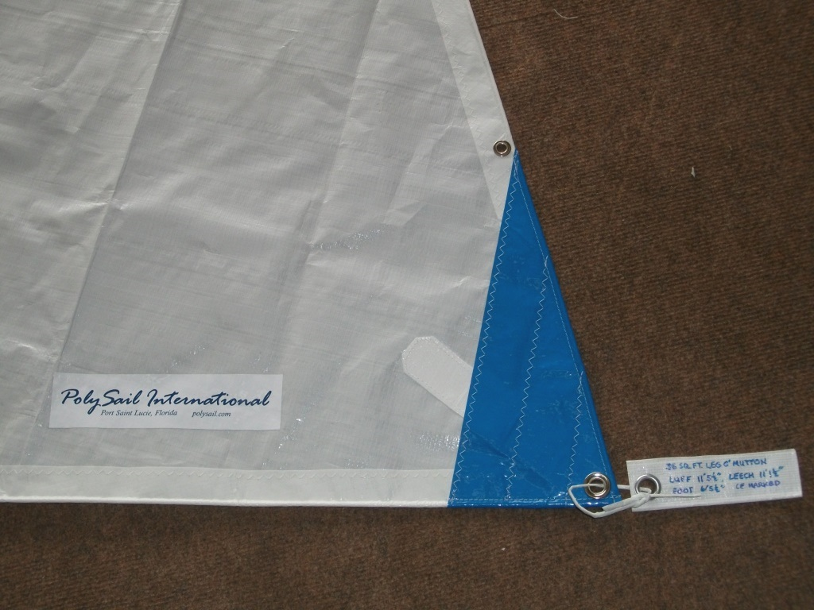

Additional sources of information on sails and sail making include:
- 103 Sailing Rigs”Straight Talk” Philip Bolger
- Boatbuilding for Beginners (and Beyond) Jim Michalak
- The Sailmaker’s Apprentice, Emiliano Marino aka Raven, the Sail Doctor

